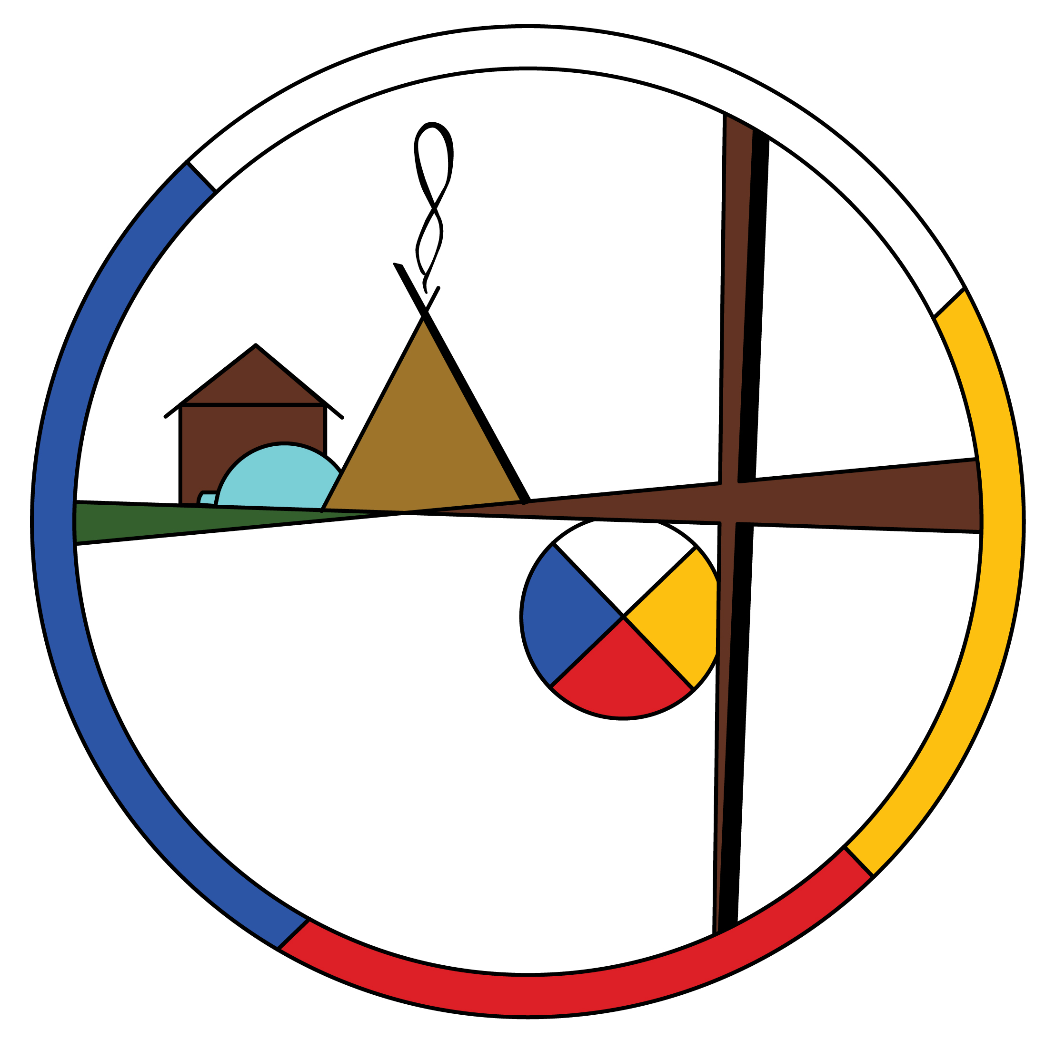
So what do we do with Proverbs?

The Reverend Dr. William Morrow
Queen’s School of Religion
St. George’s Anglican Cathedral, Kingston, ON

From the perspective of religious scholarship, corporal punishment strikes right to the heart of how Christians should interpret Scripture. Though the oft-quoted phrase “Spare the rod, spoil the child” never actually appears in the Bible, Morrow acknowledged that “that sentiment is certainly conveyed in the Book of Proverbs.”
“There are a number of passages in the Book of Proverbs that advise, or some people would say, even require parents to use corporal punishment against their children,” Morrow said.
He contends that no one passage in the Bible outright forbids the use of physical punishment against children. In the Book of Proverbs, children have essentially the same status of slaves, being subordinate to parents rather than masters.
Morrow drew a comparison with slavery as the “classic example” of an issue where Christians have been compelled to modify their interpretations of the Bible by finding larger “redemptive paradigms”.

“Gradually over time, Christian communities have come to accept that there are redemptive forces in the Scriptures, which suggest that owning slaves and being faithful to the gospels is not really in keeping with what Jesus and in fact the entire biblical canon’s redemptive paradigms were really trying to suggest or point to or vindicate,” Morrow said.

“The question that emerges for the church [regarding corporal punishment of children] is twofold, I think,” he added. “First it is how to genuinely stand up for the child in our society, and the second is … how to respond in a responsible way, in a pastoral way, to the calls for reconciliation from the TRC.

“I think that with respect to the Scriptures, you’re going to have a span of attitudes towards that, because although the church owns the Scripture as an authority, it has to balance that authority against other authorities.”

This text was excerpted from: Spare the rod: Responding to TRC call #6 for child protection and reconciliation, by Matt Gardner, Anglican.ca, Nov 3rd, 2017

